1.
Draw a simple diagram (hand-drawn or digital) showing how your phone connects to Instagram, including your device, WiFi router, ISP, and Instagram server. Label each part and the connections.
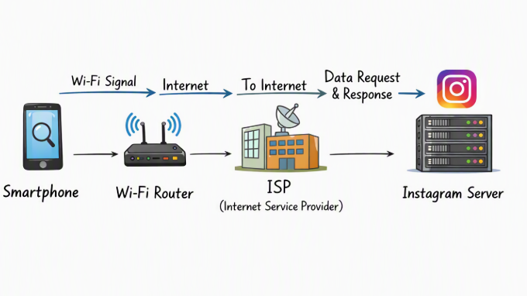

2.
List 5 devices you use or see daily that are part of a network (for example: smartphone, smart TV, WiFi router, laptop, smartwatch). For each, write what type of network it connects to (LAN, WAN, PAN, etc.).
Device | Network Type | Explanation
Smartphone | WAN (Internet) + LAN (Wi-Fi) | Connects to Wi-Fi at home and mobile data.
Laptop | LAN | Connects to home/college router for local and internet access.
Smart TV | LAN (Wi-Fi) | Streams content via home Wi-Fi network.
Wi-Fi Router | LAN + WAN | Bridges local devices to the ISP.
Smartwatch | PAN (Bluetooth) | Connects to smartphone via Bluetooth

3.
Explain the difference between the Internet and an intranet using an example from your college or a public WiFi you have used.
Internet: A global network connecting millions of devices worldwide. Example: Using public Wi-Fi at a café to browse Instagram.
Intranet: A private network restricted to an organization. Example: our college’s internal portal (GTU Student Portal) accessible only to students and staff inside the campus network.

4.
Pick any one app you use (like WhatsApp, Zomato, or Flipkart) and describe, in 4-5 lines, how data travels from your device to their server and back when you perform a search inside the app.<br><br><em><strong>Hint:</strong> Mention the devices and networks involved, and what happens when you hit 'search'.</em>
When you type a search in WhatsApp:
- Your smartphone sends the query via Wi-Fi router or mobile data.
- The request travels through your ISP into the Internet (WAN).
- It reaches WhatsApp’s servers, which process the search (e.g., finding messages or contacts).
- The server sends results back through the same path → ISP → Router → Smartphone.
- You see the search results instantly on your app.

